Objectives
- State general hormone properties and some basic functions of the endocrine system.
- Diagram feedback control in plasma glucose regulation by insulin and glucagon.
- Diagram feedback control in the GnRH-LH-estrogen control axis. Distinguish positive and negative feedback.
- Predict physiological changes with hormone changes.
- Predict physiological changes with pathologies.

Hormones are
- …chemical signals
- … released within the body (not exocrine)
- … by a cell (secretory epithelium or neuron)
- … that is transported by the circulatory system
- … that act in very small concentrations
- … on cells that have receptors for them (targets)

Major functions of hormones include: *for specifics, see charts at end
- Growth and Development
- Reproduction
- Energy metabolism (intake, production, utilization and storage of energy)
- Maintenance of the internal environment (regulation of blood volume, sodium, calcium, potassium, body temperature etc.)
- Behavioral motivation
I. Feedback control in plasma glucose regulation
Follow the steps from stimulus to response, noting that plasma glucose concentration can be regulated through the simple response of pancreatic insulin. Like any system, there are other inputs acting.
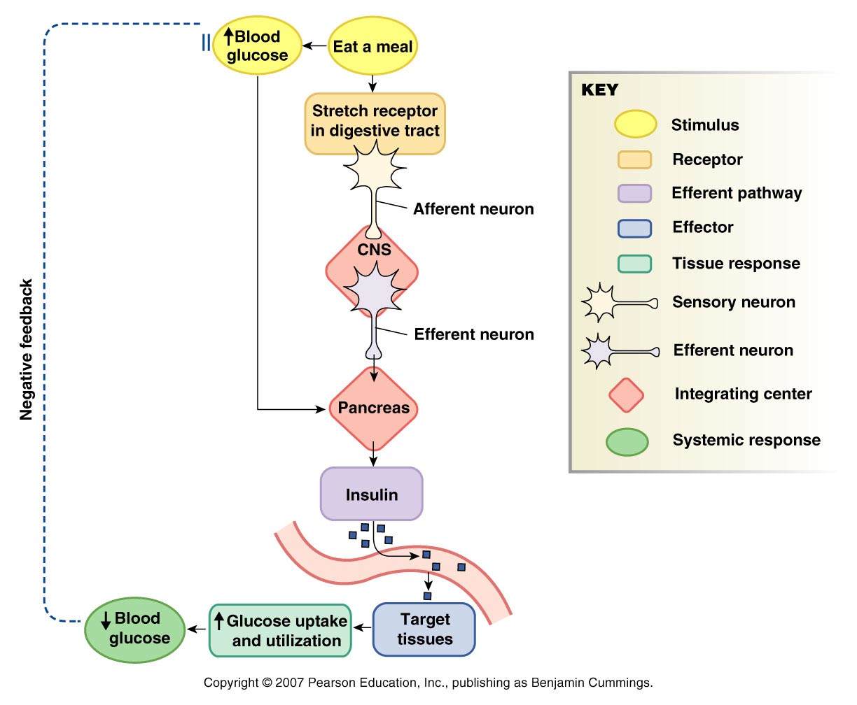

II. Feedback control of steroid hormones
The following system is more complicated because there are multiple hormones and endocrine glands within the regulatory pathway. Gonadotropin-releasing hormone (GnRH) is released from the hypothalamus, which stimulates luteinizing hormone (LH) and follicle stimulating hormone (FSH) to be released from the anterior pituitary. These hormones stimulate steroidogenesis, production of estrogen and progesterone, and gametogenesis, development of an egg, in the ovaries The basics of negative feedback control still apply; estrogen and progesterone inhibit GnRH release from the hypothalamus. We’ll examine this system in more detail in the human female.
Sex steroid control
GnRH
hypothalamus
LH/FSH
estrogen, progesterone
( - )
( + )
ovaries
negative feedback
( + )
anterior pituitary
Energetic and other cues
multiple effects

In the human female, there are two main phases of the reproductive cycle, the follicular and the luteal. Ovulation of an egg from the ovary is the event separating the two phases. The following chart shows the degree in follicle development, hormone levels and uterine endometrium thickness in the cycle.

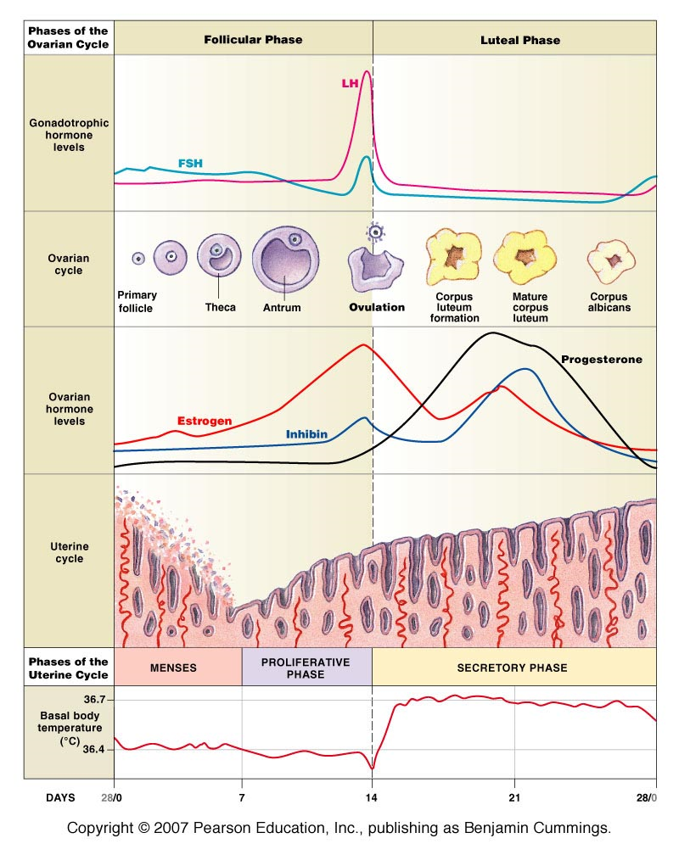

Let’s examine the hormonal feedback during the early follicular phase when there is still negative feedback within the GnRH-LH-estrogen control axis.
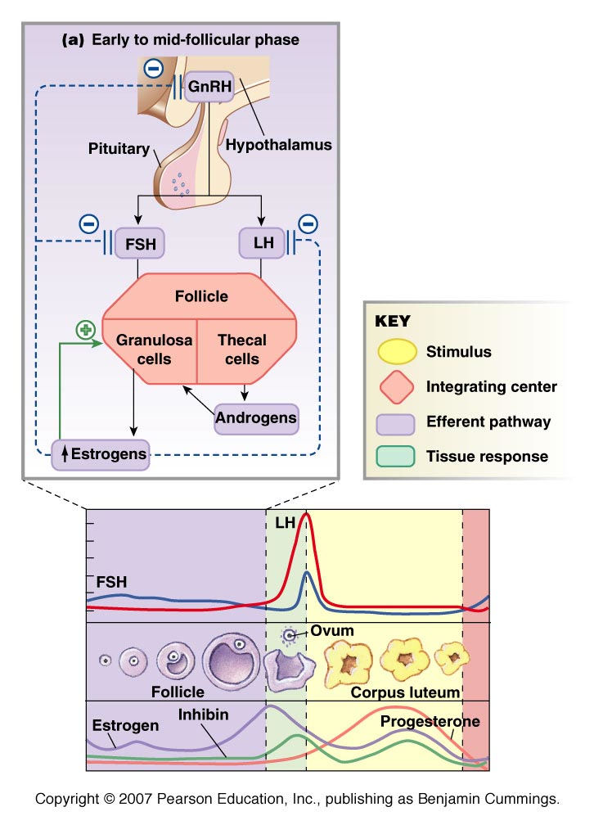

During the late follicular phase of the cycle, as estrogen secreted becomes very high, the control axis switches dramatically to positive feedback control. This causes a large spike in GnRH and then LH secretion. High LH actually causes a rupture in the ovary to release the egg… ovulation.

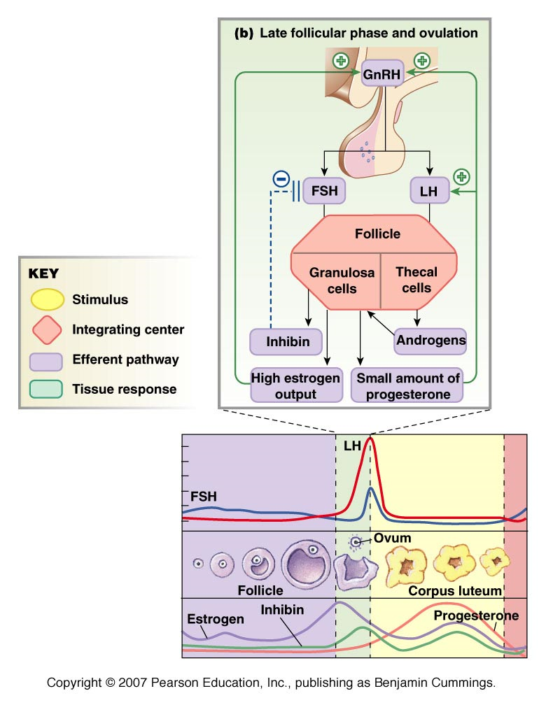

Hormone charts: secreting gland location, hormone, target, main effects


